JAVA DE
Formulario original: https://docs.google.com/forms/d/e/1FAIpQLSdacbJSexsLyC-fCKHhBG5FH2mAkAEICvTIfHLTA57NCS9rRA/viewform
Enlazado desde: Exámenes de apoyo/LINKS.docx
Preguntas y opciones extraídas del formulario público el 24-sep-2026 (solo lectura; no se respondió ni se envió). El formulario no expone la clave de respuestas, así que este documento no marca la opción correcta.
Pregunta 1 (opción única)
What is printed out when the program is executed?
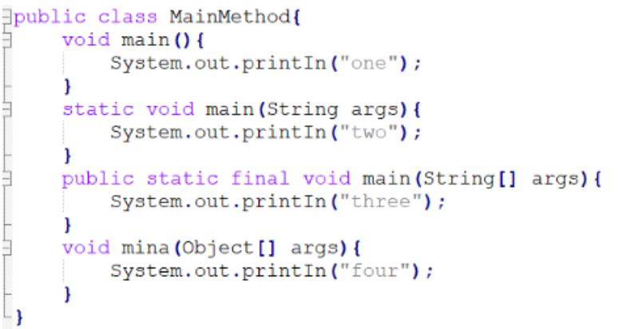
a) There is no output
b) three
c) two
d) four
e) one

Pregunta 2 (selección múltiple)
Which two statements are true?
a) An abstract class can be extended by a concrete class.
b) An abstract class can be extended by an interface.
c) An interface can be extended by an abstract class.
d) An interface CANNOT be extended by another interface.
e) An abstract class can implement an interface.
f) An abstract class CANNOT be extended by an abstract class.

Pregunta 3 (opción única)
Which declaration initializes a boolean variable?
a) - boolean k = 0;
b) - boolean m = null;
c) - boolean h = 1;
d) - boolean j = (1 < 5);

Pregunta 4 (opción única)
What is the result?
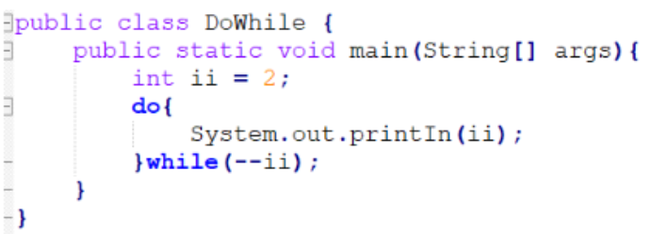
a) 1 0
b) Compilation fails.
c) 2 1 2
d) null
e) An infinite loop

Pregunta 5 (opción única)
Which two will compile, and can be run successfully using thefollowingcommand?
java Fred1 hello walls
a) abstract class Fred1 { public static void main(String[] args) {System.out.println(args[2]); } }
b) class Fred 1{ public static void main(String args) { System.out.println(args[1]); } }
c) class Fred1 { public static void main(String[] args) { System.out.println(args); } }
d) class Fred1 { public static void main(String[] args) { System.out.println(args[1]); } }

Pregunta 6 (opción única)
What is the result?
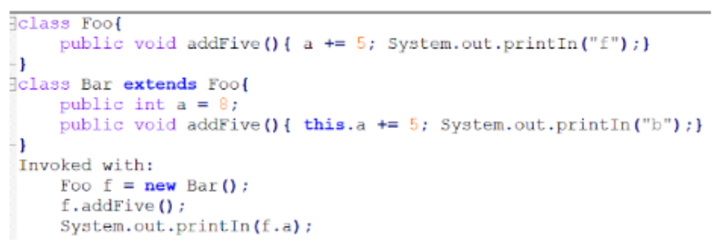
a) b 8
b) b 13
c) f 13
d) An exception is thrown at runtime.
e) b 3
f) f 8
g) Compilation fails
h) f 3

Pregunta 7 (opción única)
What is the result?
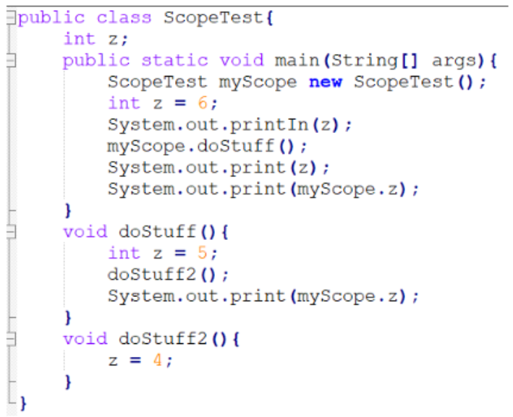
a) Compilation fails
b) 6564
c) 6565
d) 6554
e) 6566

Pregunta 8 (opción única)
What is the result?
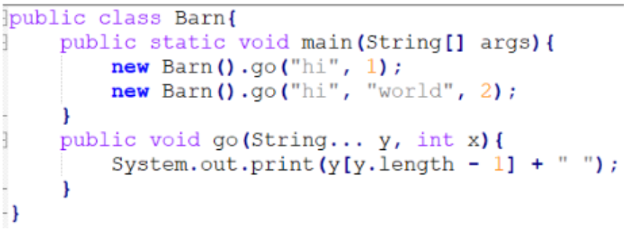
a) hi world
b) Compilation fails
c) world world.
d) An exception is thrown at runtime.
e) hi hi

Pregunta 9 (opción única)
What is the result?
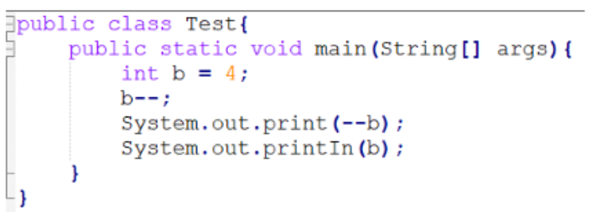
a) 32
b) 12
c) 22
d) 33

Pregunta 10 (opción única)
What is the result?
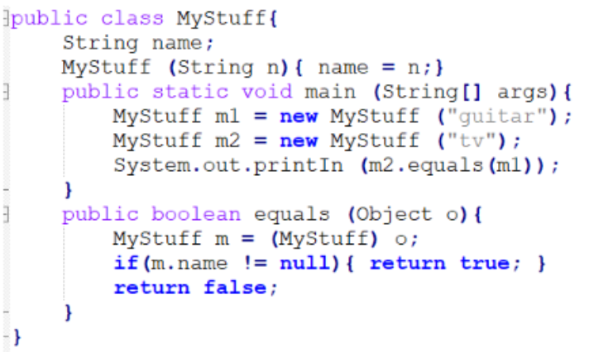
a) The output is false and MyStuff does NOT fulll the Object.equals() contract
b) The output is false and MyStuff fullls the Object.equals() contract
c) The output is true and MyStuff fullls the Object.equals() contract
d) The output is true and MyStuff does NOT fulll the Object.equals() contract

Pregunta 11 (opción única)
What is the result if you try to compile Truthy.java and then run it with assertionsenabled?
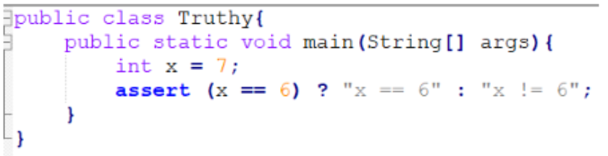
a) Truthy.java compiles and the output is x != 6
b) Truthy.java compiles and an AssertionError is thrown with no additional output
c) Truthy.java does NOT compile.
d) Truthy.java compiles and an AssertionError is thrown with x != 6 as additionaloutput.

Pregunta 12 (opción única)
Which code fragment is illegal?
a) Class Base1 { abstract class Abs1 { } }
b) Abstract class Abs2 { void doit() { } }
c) class Base3 { abstract int var1 = 89; }
d) class Base2 { abstract class Abs3 extends Base2 { } }

Pregunta 13 (opción única)
What is the result?
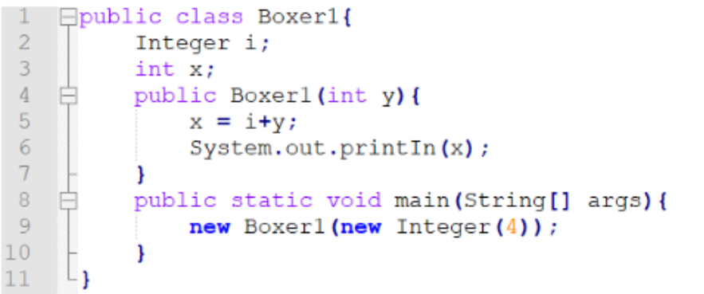
a) Compilation fails because of an error in line 5
b) The value "4" is printed at the command line.
c) A NullPointerException occurs at runtime
d) An IllegalStateException occurs at runtime.
e) Compilation fails because of an error in line 9
f) A NumberFormatException occurs at runtime

Pregunta 14 (opción única)
What is the result? Given:
a) 0 tom 0 jerry 1 tom 1 jerry
b) 0 tom 0 jerry 1 tom 2 tom 2 jerry
c) 0 tom 0 jerry 1 tom 1 jerry 2 tom 2 jerry
d) 0 tom 0 jerry 2 tom 2 jerry

Pregunta 15 (opción única)
What is the result when this program is executed?
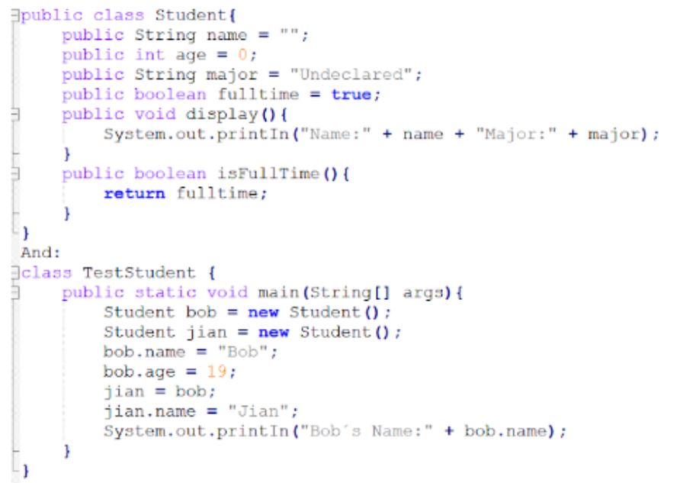
a) Bob's name.
b) Bob's Name: Jian
c) Nothing prints
d) Bob's Name: Bob.

Pregunta 16 (opción única)
The standard API for accessing databases in Java is:
a) JPA/Hibernate
b) JDBC
c) ODBC.

Pregunta 17 (opción única)
What is the result?
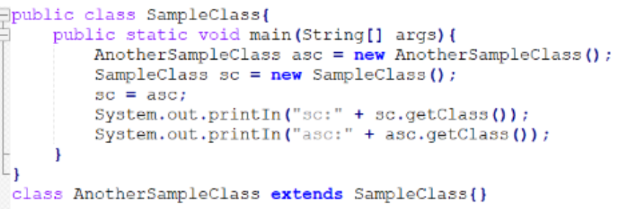
a) sc: class.AnotherSampleClass asc: class.SampleClass
b) sc: class.SampleClass asc: class.AnotherSampleClass
c) sc: class.AnotherSampleClass asc: class.AnotherSampleClass
d) sc: class.Object asc: class.AnotherSampleClass

Pregunta 18 (opción única)
Which class has a default constructor?
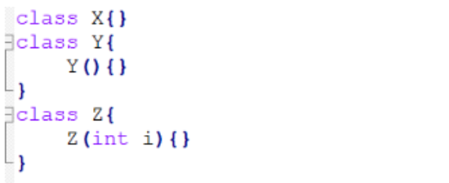
a) X and Y
b) Y only
c) X and Z
d) Y and Z
e) X, Y and Z
f) Z only.
g) X only.

Pregunta 19 (opción única)
What is the result?
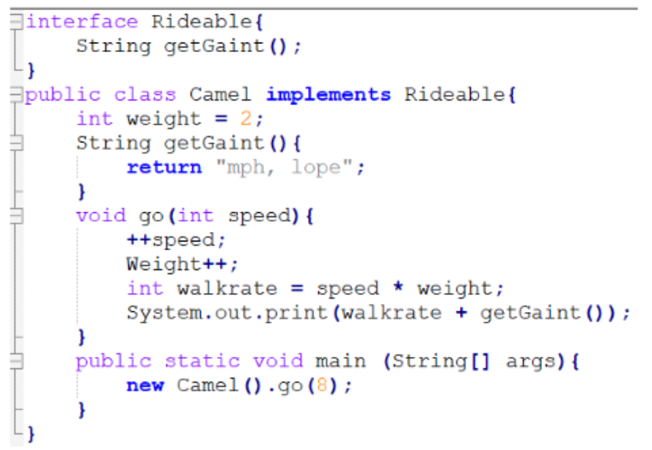
a) 27 mph, lope
b) 16 mph, lope
c) 24 mph, lope
d) Compilation fails
e) Opción 3

Pregunta 20 (opción única)
What is the result?
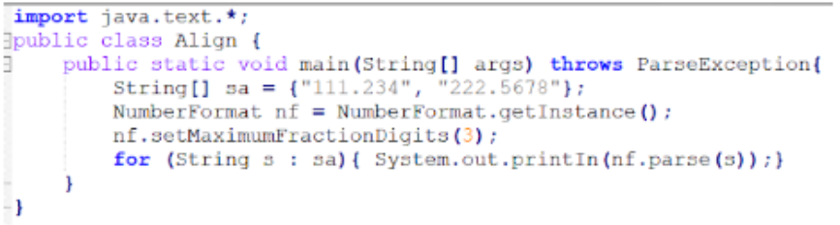
a) 111.234 222.568
b) 111.234 222.5678
c) An exception is thrown at runtime.
d) 111.234 222.567

Pregunta 21 (opción única)
Which two may precede the word "class" in a class declaration?
a) Local
b) Public
c) Synchronized
d) Volatile
e) Static

Pregunta 22 (opción única)
What values of x, y, z will produce the following
result? 1234 1234 1234 --- 1234 ---
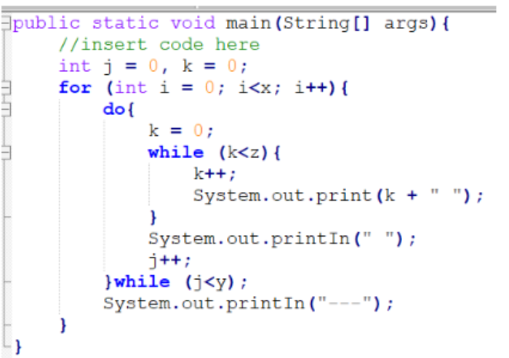
a) - int x = 4, y = 3, z = 2;
b) - int x = 2, y = 3, z = 3;
c) int x = 3, y = 2, z = 3;
d) - int x = 2, y = 3, z = 4;
e) - int x = 4, y = 2, z= 3;

Pregunta 23 (opción única)
What is the result?
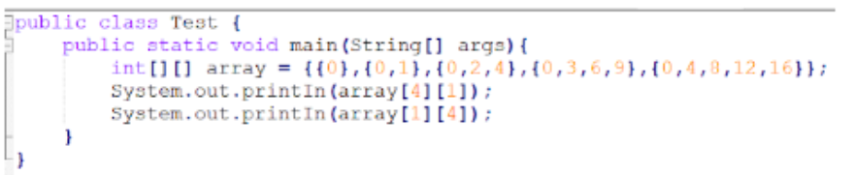
a) 4 Null
b) Null 4.
c) 4 An ArrayIndexOutOfBoundsException is thrown at run time.
d) An IllegalArgumentException is thrown at run time

Pregunta 24 (opción única)
Which three lines will compile and output "Right on!"?
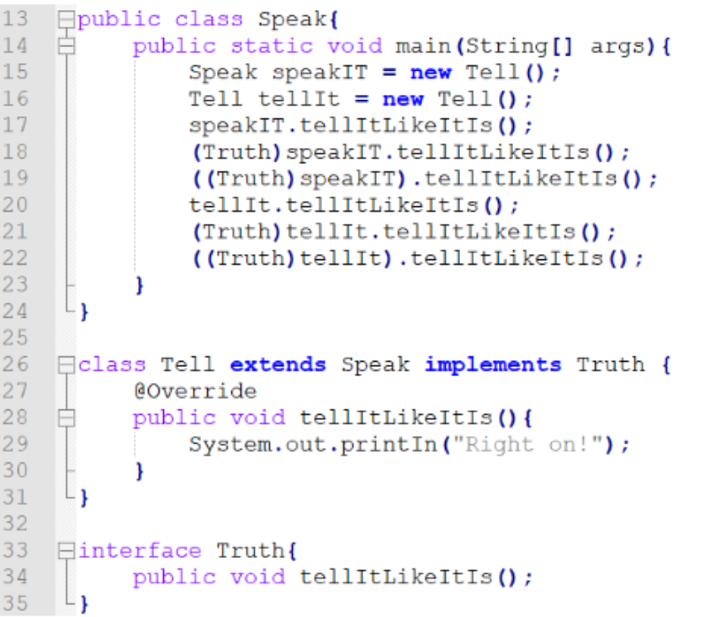
a) Line 20
b) Line 21
c) Line 18
d) Line 19
e) Line 22
f) Line 17

Pregunta 25 (opción única)
What is true about the class Wow?
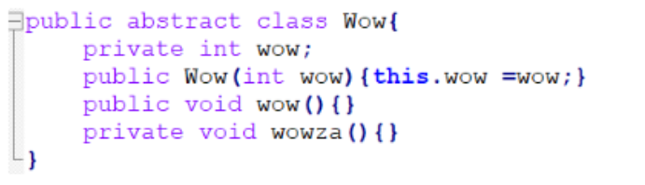
a) It does not compile because an abstract class cannot have private methods
b) It does not compile because an abstract class must have a constructor with noarguments
c) It compiles without error
d) It does not compile because an abstract class must have at least one abstractmethod.
e) It does not compile because an abstract class cannot have instance variables

